**Try Test-Connection and nslookup commands for below websites  
www.google.com  
www.facebook.com  
www.amazon.com  
www.github.com  
www.cisco.com**

**Test-Connection:** Sends ICMP Echo Requests (ping) to the specified websites to check connectivity.

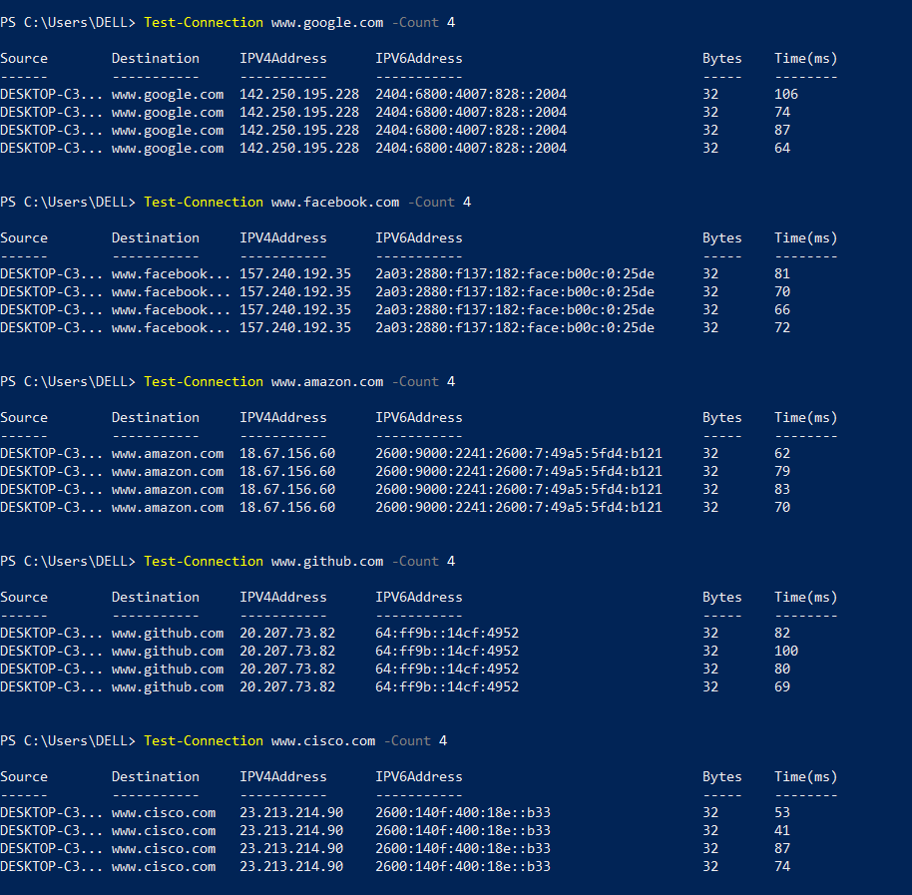

**nslookup:** Queries the DNS records of the given domains to retrieve their IP addresses.

